A snapshot of evolutionary decline for a nuclear-encoded human mitochondrial aminoacyl-tRNA synthetase
Submitted as a Research article
Constitutive co-existence of two mRNA variants of mitochondrial aspartyl-tRNA synthetase in human tissues
Hagen Schwenzer¹, Gert Scheper², Nathalie Zorn³, Luc Moulinier⁴, Aurélie Fender¹, Agnès Gaudry¹, Emmanuelle Leize³, Franck Martin¹, Olivier Poch⁴,
Catherine Florentz¹ and Marie Sissler¹*

¹ Architecture et Réactivité de l'ARN, CNRS, Université de Strasbourg, IBMC, 15 rue René Descartes, F-67084 Strasbourg Cedex, France
² Department of Pediatrics and Child Neurology, VU University Medical Center, 1081 HV Amsterdam, The Netherlands.
³ Laboratoire de Dynamique et Structure Moléculaires par Spectrométrie de Masse, Institut de Chimie Strasbourg France
⁴ Laboratoire de Bioinformatique et de Génomique Intégratives, IGBMC, 1 rue Laurent Fries BP-10142, F-67404 Illkirch Cedex, France

*to whom correspondence should be addressed: Marie Sissler, IBMC - 15 rue René Descartes, 67084 Strasbourg Cedex – France, Phone: 33 (0)3 88 41 70 62; Fax: 33 (0)3 88 60 22 18; E-mail: M.Sissler@ibmc-cnrs.unistra.fr

Key words (3 to 6):
Running head (50 characters including spaces):
List of non-standard abbreviations: AaRS: aminoacyl-tRNA synthetase (specificity is indicated by the name of the amino acid (abbreviated in a one-letter code) transferred to the cognate tRNA. As an example, AspRS stands for aspartyl-tRNA synthetase), MTS: mitochondrial targeting sequence

ABSTRACT (250 words)
Background
Mammalian mt-aaRSs are nuclear-encoded and fulfill their activity in the mitochondrion. They have complex evolutionary histories (endosymbiotic origin + post-endosymbiotic events) so that they have diverse origins/ancestor. Characterization (on their structure / function / evolution) is in progress. Here, mt-AspRS, of bacterial origin. Detection of a second amplicon during cloning of recombinant mt-AspRS
Purpose
Characterize the amplicon RNA, evaluate its functionality, and decipher its meaning/pertinence.
Method
In vitro, in vivo, bioinformatics
Results
This amplicon RNA corresponds to a full messenger RNA of an alternative form of mt-AspRS, with the deletion of precisely one exon, in a region coding for the so-called “bacterial insertion domain”. The spliced mRNA is present in all tested tissues, co-exists with the full-length form, but there is no sign for expression of the corresponding protein in vivo. Bioinformatics reveals (confirms) the lost of selective pressure within this region for all mitochondrial sequences, while a strong selective pressure is preserved in all bacterial related sequences. mRNAs with deletion of neighboring exons are present in other organisms.
Conclusion
mRNA is present but the related protein is unstable
Interpretation: snapshot of evolutionary decline

INTRODUCTION

accroche = ARN place importante dans le monde du vivant : Il se trouve que l’on a trouvé de manière serendipitous un amplicon
possibilité que l’on ai pas rencontrer les conditions dans lesquelles la prot se produit (tel que conditions de stress)
Fonction des ARN en tant que tel / maointenance d’un role fonctionnel / dans un état de stress particulier / conditions pas encore visités / Il a un rôle

Aminoacyl-tRNA synthetases (aaRSs) are housekeeping enzymes involved in the essential process of protein biosynthesis, i.e. the translation of the genetic information from mRNA into proteins. In every cell and organelle, each of the 20 aaRSs esterifies specifically its corresponding tRNA(s) with the correct amino acid, which is then transferred to the growing peptide chain on the ribosome. AaRSs have been extensively explored during the past decades to unravel their structural, functional and evolutionary properties (reviewed in e.g. {Cusack, 1997 #4071; Giegé, 1998 #3993; Ibba, 2005 #6629; Guo, 2010 #7790}). In human mitochondria, protein biosynthesis is dedicated to the production of 13 proteins, all sub-units of the respiratory chain complexes, which are the seats for energy production (reviewed in {Florentz, 2003 #6644}). Human mitochondria possess a specific set of aaRSs, all encoded by the nuclear genome, synthesized within the cytosol and imported into the mitochondria thanks to the presence of a mitochondrial (mt) targeting sequence (MTS) {Sissler, 2005 #7146}. Their genes differ from the ones encoding cytosolic-addressed aaRSs, with solely two exceptions (GlyRSs and LysRSs, {Bonnefond, 2005 #7138}). Despite the conventional view of the endosymbiotic origin of mitochondria {Gray, 1999 #4688}, the source of nuclear gene for mt-addressed aaRSs is diverse, reflecting numerous post-endosymbiotic and/or lateral gene transfer events {Brindefalk, 2007 #7513}. Nevertheless, many of the mt-aaRSs originate from within the bacterial domain, as it is the case for instance for human mt-aspartyl-tRNA synthetase (mt-AspRS, {Bonnefond, 2005 #7138}) with the sole exception of trypanosomatids where the two AspRSs are of eukaryotic type (Charriere et al., 2009).
Human mt-AspRS shares 43% of identical residues (including residues specific for all AspRSs), the same secondary structure organization (including the bacterial-type insertion and C-terminal extension domains), and a same architecture (as recently established, {Neuenfeldt, 2012 #7812}) with Escherichia coli AspRS, a representative bacterial homolog. However and despite the two enzymes are likely descendants from a common ancestor, numerous functional idiosyncrasies/discrepancies were reported for human mt-AspRS when compared to E. coli AspRS. These concern a reduced catalytic efficiency {Bonnefond, 2005 #7138; Sissler, 2005 #7146}, the requirement of a minimal set of determinants within cognate tRNA {Fender, 2006 #7248}, a higher sensitivity to small substrate analogs {Messmer, 2009 #7720}, the lack of cross aminoacylation of bacterial tRNA {Fender, 2012 #7811}, and an increased plasticity of the mitochondrial enzyme when compared to its bacterial homolog {Neuenfeldt, 2012 #7812}.
Having in mind the necessity to enlarge the knowledge on mt-AspRS, the purpose of the present study was to characterize an amplicon RNA, an alternatively spliced form of the mt-AspRS-encoding mRNA, and to evaluate its functionality and decipher its meaning. We demonstrate that it is derived from mt-AspRS mRNA sequence, missing a full exon (exon13), that both full-length and exon13-deleted mRNAs co-exist in all tested human tissues, are processed and handled by the polysomes, but that the protein corresponding to the spliced-form is not retrieved as a stable protein. Sequence and conservation analysis (multiple sequence alignment) and the discovery (within databases) in other organisms (preciser lesquels : mammals, vertebrates, ….?) of other forms of mt-AspRS with variable insertion domains favor the hypothesis of the loss of function of the bacterial insertion domain for AspRSs of mitochondrial location, and thus the loss of selective pressure to keep the domain intact. Splicing alternatif is occurring here as neofunctionality = simplification Thus the existence of Dexon13 variant in human is a snapshot of the evolutionary decline towards a simplified version of mt-AspRS, likely deprived of bacterial insertion domain (as it is the case for cytosolic or archaeal sequences)

MATERIALS AND METHODS

Cell culture
HEK (Human Embryonic Kidney)-293, COS-7 (CV-1 African green monkey kidney line carrying the SV40 genetic material, gift from A. Lescure, Strasbourg Do we have to keep = does it gave some results ???? gift from A. Lescure, Strasbourg) and HEPA1-6 (mouse hepatoma cells, gift from M. Frugier, Strasbourg) cells were maintained in DMEM (Dulbecco’s modified Eagle’s medium, Invitrogen) supplemented with 10% FCS (fetal calf serum), 100 units/ml penicillin and 100 μg/ml streptomycin at 37°C, in a 10% CO₂ humidified incubator. BHK (Baby Hamster Kidney)-21 cells (ATCC # CRL-12072) were cultivated in GMEM (Glasgow modification of Minimum Essential Medium, Invitrogen) supplemented with 10% FCS and 1.5 g/ml bacto-tryptose phosphate.

PCR amplification of mt-AspRS coding sequence (Human AND MOUSE)
Mt-AspRS coding sequence was amplified from a human cDNA library (from where?) using Dynazyme EXT polymerase (Finnzymes). Primers for PCR were designed to amplify the mature enzymes, i.e. deprived of its theoretical MTS {Bonnefond, 2005 #7116} at its N-terminus (see Supplementary Fig. 1). PCR products were directly used for cloning into pCR2.1® following the TA Cloning Kit protocol (Invitrogen). After transformation of One Shot TOP10 E. coli cells (Invitrogen), plasmid DNA was purified and sequenced {Bonnefond, 2005 #7116}.
Complete with what has done in mouse : Amplification of 2 mRNAs – extraction _ cloning and sequencing / combined directly on the text in other not to make two separate paragraphs
Add eventually and if relevant data on Chimpanzee

RT-PCR of mt-AspRS in different tissues
cDNA synthesis, DNA amplification and quantitative PCR were carried out as described before {van Kollenburg, 2006 #7565}. Human total RNAs from 20 tissues were purchased from Ambion (FirstChoice® Human Total RNA Survey Panel) or purified from HEK cells as described before {Chomczynski, 1987 #4565}. Primer sequences and target sites were as described in Supplementary Fig. 1. qPCR values obtained for each tissue were corrected for GAPDH mRNA levels. Relative expression level of Dexon13 variant was calculated using the ΔΔCt method.

Recombinant protein expression in mammalian cell
Recombinant proteins (mt-AspRS or mt-AspRS-Δexon13) were expressed in BHK cells using the transient MVA-T7 (Modified Vaccinia Virus Ankara) transfection-infection approach as described in {Jester, 2011 #7813}. Briefly, BHK-21 cells were grown for 24 h on 10 cm culture dishes, infected with a mixture containing MVA-T7 and 20 µg of plasmid DNA. 30 minutes after infection, cells were induced with 1 mM IPTG. After 24-48 h, cells were harvested by scraping and centrifuging to obtain cell pellets. Crude protein extracts were recovered from the pellets using Pierce RIPA buffer (Rockford, IL, USA) containing 1x protease arrest (GBiosience, USA) following the manufactures instructions.

Sucrose-Gradient Analysis
HEK293 cells were spread on 30x 150 mm dishes. At 75% confluence, cells were harvested, washed 3 times in phosphate-buffered saline (PBS) and resuspended in lysis buffer (10 mM Hepes pH 7.5, 10 mM KAc, 0.5 mM MgAc, 5 mM DTT) and lysed by 20 strokes with a syringe. After centrifugation at 13000g, the cleared supernatant was concentrated in a centrifugal filter device (cutoff 10 kDa). The poly-ribosomes were separated from 80S ribosomes and free RNA on a 7%–47% linear sucrose gradient (25 mM Tris-HCl pH 7.4, 50 mM KCl, 5 mM MgCl₂, 1 mM DTE, 1 mM AEBSF) in a swing out rotor for 2,5 hr at 234116xg at 4°C. Gradients were fractionated, Phenol/Chloroform extraction of RNA were performed {Chomczynski, 1987 #4565}. Two microgram of total RNA were reverse transcribed following the First Strand cDNA synthesis kit protocol (Fermentas). Mt-aaRS sequences were amplified as described above. PCR products were purified and cloned into pCR blunt II vector following the instructions of the Zero Blunt® PCR Cloning Kit (Invitrogene). Plasmids were sequence as described above.

LC-MS/MS analysis
XXXXX

Generation of the Multiple Alignment of Complete Sequences
Sequences of the mitochondrial AspRS proteins were examined in 63 eukaryotic organisms with: 15 Metazoa, 40 Fungi, 9 Archaeplastida (Viridiplantae) and 15 Protists (4 Excavata, 8 Chomalveolata, 2 Amoeboza and 1 Choanoflagellida, a close lineage of Metazoa). To obtain an objective evaluation of the sequence divergence, the bacterial homologues were retrieved form 120 organisms encompassing all bacterial subgroups and removing redundancy by counting only non-identical sequences. The complete list of species is provided in the Supplementary dataset Table 1.
Initial BlastP searches [47] were conducted at the National Center for Biotechnology Information site (http://www.ncbi.nlm.nih.gov/BLAST) in the non-redundant protein database (E≤0.001) using H. sapiens, S. cerevisiae and E. coli proteins as queries. When necessary, additional similarity searches were performed at the genomic level using TblastN to uncover potentially missing or mispredicted proteins. The likely homologous sequences detected by BLAST searches were aligned using PipeAlign [48] providing a final Multiple Sequence Alignment (MSA) quality of which was objectively evaluated using the NorMD (normalized Mean Distance) (Thompson, 2001). Finally, the manual verification and correction, paying attention to secondary structures based on the bacterial and human mitochondrial protein AspRS structures found in the PDB database (PDBCode, 1L0W thermos thermophilus, 1c0A Escherichia coli, 4AH6 Homo sapiens mitochondrial), was performed using ORDALIE alignment viewer and editor (manuscript in preparation). Subfamilies were automatically defined using DPC (Density of Point Clustering) {Wicker, 2002 #11} and validated by human expertise on the basis of global conservation, domain organization and inter-subfamily residue conservation analysis. The complete alignment of the bacterial and mitochondrial AspRS protein sequences is available at http://lbgi.igbmc.fr/puzz/.

Sequence Analysis
Sequence conservation within each family was estimated using the ORDALIE software (manuscript in preparation) to evaluate various conservation scores corresponding to the global and pairwise sequence identities and similarities between various sets of complete sequences including i) the 180 organisms; ii) the subfamilies; iii) SLIDING WINDOWS
To identify the domains and motifs present in the proteins, the MSA was scanned using
Interproscan and the InterPro database [23].

The FamID defines the conservation within each subfamily and is calculated as the mean of all pairwise percent identities and the positions in the alignment with gaps within the subfamily are excluded from the calculation.

where: n = total number of sequence tested, S_{i} and S_{j} the ith and jth sequence and
= pairwise percent identity between the ith and jth sequence, excluding gap regions.

Phylogeny (dans supplementary)
In order to reconstruct the phylogeny, we used the complete sequences as well as the sequence of the Bacterial Insertion Domain of all aligned mtAspRSs. We excluded the following sequences because of incompleteness or poor prediction: xxx, xxx, xxx. To clarify the overall topology of the family; xxx sequences from the cytosolic AspRs were included as an outgroup. We used the neighbor joining algorithm implemented in Phylowin with 500 bootstraps to generate the phylogenetic tree [24]. For tree visualization and editing we used iTOL [25].

RESULTS

1. Co-existence of 2 mRNAs for human and mouse mitochondrial aspartyl-tRNA synthetase + Mouse ?
To clone coding sequence of the human mt-AspRS, the corresponding region was amplified by PCR from a human cDNA library. Forward and reverse primers were designed according to previous gene annotation and in order to match sequence coding for mature protein, i.e. without its predicted MTS {Bonnefond, 2005 #7116} (Supplementary Fig. 1). In addition to the PCR product of expected size, one shorter DNA fragment was amplified (Fig. 1A). Sequencing of the two PCR products identified a gap of 153 nucleotides (in the bottom size amplicon), corresponding exactly to exon 13 of the mt-AspRS sequence (of full-length in the top-size amplicon). Deletion of exon 13 does not affect the downstream reading frame and shortens the translated sequence by 51 amino acids. Amplification of the full-length mRNA with primers specific to 5'- and 3'-UTRs (Supplementary Fig. 1) and sequencing, confirmed the presence of a MTS also for the alternative splice transcript mt-AspRS-Δexon13 (Fig. 1B), suggesting a mitochondrial location of the corresponding protein, if expressed and stable. Add data for the mouse … Similarly … blabla absence of Exon 12, a symmetric exon, coding for XXX aa XXXX
The region of human mt-AspRS containing exon 13 was amplified from cDNAs derived from total mRNAs extracted from 20 human tissues. As seen in figure 2A, two PCR products were retrieved from all investigated tissues. This holds true also in immortalized lymphoblasts (not shown). Sequence analysis confirmed the presence or the absence of exon 13 respectively in the DNA fragments of high and low molecular weight. The relative abundance of full-length and the Δexon13-variant mRNAs were measured by quantitative PCR (qPCR) in each cDNA sample. Two primer sets, one that detects both the full-length and the Δexon13-variant mRNAs and one specific to the splice-variant spanning the exon 12/exon 14 boundary, were used (Supplementary Fig. 1). The shorter fragment was present in a range of 4% to 15% (Fig. 2B), with the highest level in skeletal muscle (15%) and the lowest level in esophagus, ovary, small intestine and trachea (4%). This demonstrates the wide distribution of mt-AspRS- Δexon13 mRNA in all tested human tissues.

2. Human mt-AspRS-Δexon13 mRNA is polyadenylated and handled by polysomes
Polyadenylated total mRNAs, extracted from HEK293 cells, were reverse transcribed using oligo-dT primers. Subsequent amplification with mt-AspRS gene-specific oligonucleotides provided the two expected DNA fragments. Sequence analysis demonstrated that the high and low molecular weight DNAs correspond respectively to the polyadenylated full-length and Δexon13-variant transcripts (data not shown).
In order to investigate the possibility that full-length and Δexon13 mRNAs are both handled by the translation machinery and expressed, all polysome-bounded mRNAs were retrieved from polyribosomal fractions purified by sucrose sedimentation of crude cellular extract from HEK293 cells (Supplementary Fig. 2). The two mRNAs were detected by RT-PCR amplification, and their sequences were confirmed after retrieval and cloning of the amplicons.

3. Absence of detection of the protein corresponding to human mt-AspRS-Δexon13
In order to characterize structural and functional properties of human mt-AspRS-Δexon13 in vitro, attempts to clone and express the protein were undertaken according to the procedure, which successfully lead to recombinant full-length mature mt-AspRS {Bonnefond, 2005 #7116}. This approach was unsuccessful when applied on mt-AspRS-Δexon13 even under a large number of alternate cloning strategies including fusions to the maltose binding protein (MBP) {Nallamsetty, 2005 #7454}, and/or to “peri” {Nallamsetty, 2005 #7454} or “ompA” {Hytönen, 2004 #7562} secretion signals allowing targeting of the protein to the periplasm. Multiple bacterial strains were tested, among which some expressing chaperone proteins {Ferrer, 2004 #7563}. All along, different cell growth conditions were investigated (see Supplementary Methods). One condition led to low yield of soluble protein, however contaminated with non-reversely bound chaperones. This fraction retains an aminoacylation activity estimated 700-fold lower than the one of full-length mt-AspRS (data not shown).
In a second attempt, in cellulo expression of mt-AspRS-Δexon13 has been considered. Plasmid containing either the full-length sequence of mt-AspRS or the spliced sequence, both upstream the sequence of a flag-tag (DYKDDDDK), was introduced into mammalian cells (BHK21, baby hamster kidney cells) following the procedure described in {Jester, 2011 #7813}. After cell growth and crude protein extracts preparation, detection of recombinant proteins was performed by western blot using a monoclonal antibody specific for the Flag peptide. While a flag-tagged protein is detected in cells expressing the full-length mt-AspRS, no signal is retrieved from cells expressing mt-AspRS-Δexon13 (not shown), suggesting either non-expression or non-stability of the splice variant.
Another attempt consisted on the in vivo detection of mt-AspRS-∆exon13 by mass spectrometry. The peptide R₃₈₈NFAADHFNQ/CSLLGK₄₀₃ corresponds to the boundary exon 12/exon 14 -encoded regions, is experimentally generated by trypsin digestion (as verified on recombinant protein, not shown), and is specific to mt-AspRS-∆exon13 (not found in any other human protein as verified when screening human sequences database). This specific peptide was searched for by LC-MS/MS on crude protein extracts, extracted from mitochondria (~400 mg of wet mitochondrial pellet) purified out of ~2.10⁸ human cells (either HEK293 or myoblasts), and separated on either 1-D or 2-D gel electrophoresis. The detection limit of LC-MS/MS experiment is estimated around 100 ng of protein (REF). Western blot detections on a standard range of known concentrations of mt-AspRS were performed (not shown) and allowed to estimate an approximate amount of 8 µg of mt-AspRSs per 2.10⁸ cells. The estimated expression level of mt-AspRS-∆exon13 (based on mRNAs ratios) is 5-10% as compared to the full-length sequence leading to a theoretical amount of ~400 to ~800 ng of protein produced from the spliced variant, a value 4 to 8 times above the theoretical detection level. However, despite being under good theoretical experimental conditions, the boundary peptide could not be detected (while peptides corresponding to full-length mt-AspRS were retrieved), suggesting that additional factors (such as e.g. low stability of the protein) may limit the detection of mt-AspRS-∆exon13 in vivo. In order to exclude an unexpected sub cellular localization, similar experiments were performed with crude cellular extracts, with no further success.

4. Different selective pressures within bacterial insertion domains of AspRSs
The AspRS evolution has been extensively studied (Refs) emphasizing that this nuclear-encoded protein of mitochondrial location, present in all eukaryotes, is from bacterial origin (Bonnefond, Brindelfalk), with the sole exception of trypanosomatids where the two AspRSs are of eukaryotic type (Charriere et al., 2009). To determine precisely the conservation patterns of mt-AspRS subfamily proteins across an extensive range of organisms, we searched within XXX completed genomes for the presence of mt-AspRS and bacterial AspRS genes (see Supplementary Table xxx for a complete list) and performed sequence analysis on the basis of a structurally and manually refined sequence alignment of the XXX sequences (Figure xx and/or Supplementary Figure xx). As previously shown (Refs), this analysis confirms that, from bacteria to eukaryotes, all studied sequences (AspRSs of bacterial type) share common domain architecture (Fig XA) with the N-terminal anticodon-binding domain, the hinge region, the catalytic domain embedding the 3 class II signature motifs and the so-called Bacterial Insertion Domain and finally, the C-terminal bacterial extension. Mitochondrial sequences have in addition an N-terminal MTS.
As exemplified by the phylogenetic analysis (Fig XXX phylo tree or supplementary) performed on the aligned AspRS sequences, the bacterial AspRS and the viridiplanta mt-AspRS are closely related while the remaining mt-AspRS sequences are more divergent and dispersed on separate branches corresponding to fungi, metazoan and protists. The stronger conservation of the bacterial and plant enzymes is further confirmed by the amino acid identity percentages calculated for each pair of sequences which range between 39.4 and 93.9% (mean 51.5%) while the percentages observed for the other eukaryotic enzymes range from 25.1% up to 85.4% (mean 36.3%). To further investigate the conservation patterns present in the bacterial and mt-AspRS sequences, mean percent identities using a sliding-window of 50 residues were calculated using the sequences from all organisms or from distinct subsets of organisms corresponding to the viridiplanta, the bacteria, the fungi and the metazoan plus protist (Fig XXX). This analysis emphasizes firstly, that the sequence conservations are not uniformly distributed but rather differentially scattered between the distinct functional domains and secondly, that the differential conservation pattern distinguishing bacterial and viridiplanta from the fungi, metazoan and protists is mainly linked to the highly divergent Bacterial Insertion Domain observed in the latter subgroups. Indeed, while the conservation scores obtained for the bacterial and viridiplanta subgroups are globally similar along the distinct domains, when calculated in either the fungi or the protists and metazoan subgroups, the scores drop down dramatically for the BID domain, emphasizing the weaker selective pressure at work in the ophistokont (fungal and metazoan) and protist sequences.

Stats identity sur Extra Domaine

groupe GroupeToutLeMonde
moyenne 24.714862722110375
std. dev. 13.58863882090405
min pci 2.0618556701030926
max pci 91.66666666666666

groupe Group1 Fungi
moyenne 24.341842268571014
std. dev. 14.435071427480528
min pci 6.185567010309279
max pci 76.19047619047619

groupe Group2 Animax
moyenne 19.320151978112218
std. dev. 8.368398314035668
min pci 4.938271604938271
max pci 72.44897959183673

groupe Group3 Plants
moyenne 43.21979380600599
std. dev. 10.496040144829482
min pci 25.263157894736842
max pci 74.25742574257426

groupe Group4 Bacteria
moyenne 40.09281849901171
std. dev. 9.789434661886574
min pci 14.736842105263156
max pci 91.66666666666666

To further advance our analysis, we focused on the Bacterial Insertion Domain to identify specific residues or motifs that may underlie the observed differential conservation behavior. This allowed us to uncover the striking conservation of two motifs “G(L,I)Φ(Y,W,Φ)” (where Φ stands for hydrophobic residues, located at between residues 348 – 351 following E. coli numbering) and “PVAK” (aa 367 – 370 following E. coli numbering) which are common to all bacterial and Viridiplantae sequences and strictly absent in the other sequences (Fig XX). It is to notice that the extensive sequence divergence observed between the fungal, metazoan and protists sequences imply that no specific residue or motif common the 3 groups could be identified. Rather, we could detect some conserved residues/motifs (xx in position xx; xxx in position xxx), which unambiguously distinguish different clades in the fungal group. Altogether, these data strongly suggest that XXXX

Parts with PhyloP ???
DISCUSSION
1. The first sentence should repeat the question written in the Introduction … and the first statement should be the answer of this question.
2. Than review of the most important findings, whether or not they support the original hypothesis and whether they agree with the findings of other researchers.
3. Possible explanations for or speculations about the findings.
4. Limitation of the study that restrict the extent to which the findings can be generalized.
5. Implications of the study (generalizations from the results).
6. Recommendations for future research and practical applications.

The purpose of the present study was to evaluate the role and decipher the meaning of a serendipitously amplified PCR fragment, which coding sequence corresponds to a deleted version of human mt-AspRS. We show that the amplicon corresponds to a full mRNA coding for a variant missing precisely the symmetric exon 13, encoding a peptide in the so-called bacterial insertion domain (BID). The spliced mRNA possesses 5’- and 3’-UTRs, a polyA tail, is bound to polysomes, and is present in all tested tissues together with the wild-type mRNA, excluding the possibility that it would have been produced from a pseudo-gene. In our hands and under our experimental conditions, the corresponding protein is nearly impossible to express in vitro and is not detectable in cellulo or in vivo, strongly suggesting a decreased stability. Localization of the exon 13-encoded peptide on the crystallographic structure of human mt-AspRS (Neuenfeldt 2012) is of help to understand possible instability of the protein. Excision of this peptide occurs at extremities of well-defined structural domains (Fig. 4) and the start and the end of the peptide are adjacent in the 3D structure. However, this excision removes half of a ß-sheet and leaves one of the major ß-strand alone, disrupting inter-strands hydrogen bounding, and thus disrupting inter-strands stability.
transition
Sequence comparisons of human mt-AspRS with other AspRSs (intégrer la description des résultats d’Olivier )revealed that the organelle enzyme exhibits the typical bacterial insertion (aa 328 – 456) and C-terminal extension (aa 607 – 645) domains, which indicates its bacterial nature (Bonnefond et al., 2005). As an example, mt-AspRS and E. coli AspRS are closely related enzymes with a same organization and 43% amino acid identity. Figure 4X shows the organization of mt-AspRS and the localization of exon 13-encoded peptide in the BID. This domain is alternatively named GAD, named after its retrieval in both some Glutamyl-tRNA Amidotransferase and bacterial-type AspRSs (DRS). Its function remains however un-deciphered. Exploration of topology conservation leads to some hints (reviewed in Giegé & Rees 2005, ds bouquin d’Ibba). (Simplifier ce qui suit ) Composed by more than 130 residues, this domain consists of a four-stranded ß-sheet surrounded by two anti-parallel a-helices on the side facing the active-site core, and smaller helices on the side facing the solvent (Delarue 1994, EMBO J , Fig.4 XX). A similar fold, called the ferredoxin fold has been observed in other proteins, in particular glutamine synthase (Almassy 1986), nucleoside diphosphate kinase (Janin, Dumas, 2000), histidine-containing phosphocarrier protein (HPr, implicated in phosphate binding and phosphorylation) (Delarue 1994, EMBO J), or in many nucleotide or polynucleotide-binding proteins. In E. coli AspRS (Fig. 4XX) the ferredoxine-like fold is made up of a three-stranded ß-sheet (ß₁a₁ß₂ß₃a₂). Interestingly as well, sequence alignments of bacterial AspRSs (Fig. XXX) revealed the striking conservation of two motifs within the insertion domain, as already observed previously (Moulinier, Thèse ULP). Motifs “G(L,I)Φ(Y,W,Φ)” (where Φ stands for hydrophobic residues, located at between residues 348 – 351 following E. coli numbering) and “PVAK” (aa 367 – 370 following E. coli numbering) are well conserved in bacterial sequences. Altogether, topology conservation and motifs conservation demonstrate the specific and strong selective pressure that is exerted on insertion domain from bacterial and viridaeplantae AspRSs towards potential important catalytic/functional mechanisms and/or interactions with partners. None of the above-mentioned topology and sequence motifs conservations is visible within BID from mitochondrial AspRSs sequences, highlighting the clear release of selective pressure, and likely the clear loss of function, on this domain for AspRSs of mitochondrial location. Comportement clairement different entre eukaryotes (-plantes) et bactéries
Then, data on mouse, revealing that pseudoexonization is occurring as well but on another part of the BID XXXX et l’absence théorique dans d’autres organisms [Complement: find within websites other splice variants of AspRS within differents organisms, where other exons within BID (Exon 11 – Exon 12 – Exon 13) are alternatively spliced (mRNAs with deletion of neighboring exons are present in other organisms) = meaning that pseudoexonization is possible in BID = emphasizing the lost of selective pressure, and thus, the lost of function.

Pseudoexonization = when an exon is going back to a non-coding region

Analysis of protein sequences and three-dimensional structures has revealed that many proteins are composed of a number of discrete domains. These so-called mosaic proteins are particularly abundant in the metazoan phyla. The individual domains of a mosaic protein are often involved in specific functions that contribute to its overall activity.
(Joost A. Kolkman¹ & Willem P.C. Stemmer “Directed evolution of proteins by exon shuffling” Nature Biotechnology 19, 423 - 428 (2001))

{Keren, 2010 #7868} : What are the evolutionary forces that shaped, and continue to shape Alternative splicing ?
It is well demonstrated/Accepted that alternative splicing serves as a testing ground for molecular evolution {Ermakova, 2006 #7866}

Accepted concept of variant is duplication for neo-functionality (co-existence of 2 proteins allows for multi-functionality). Here, an example of neo-functionality = simplification

{Kelemen, 2013 #7867}: There is always an evolutionary advantage for an exon to be used alternatively = here, the evolutionary advantage is the simplification of the protein.
The amount of alternative splicing increases from invertebrates to vertebrates, suggesting that the generation of new alternative exons could be a driving force in evolution
An exon is symmetric when it can be divided by 3, which indicates that it keeps the reading frame.
{Boue, 2003 #7548} : Alternative splicing increases transcriptome diversity and allows a specific expression of transcipts at precise time point in specific tissues (attention, probablement via alternate polyadenylation )…….. If a new exon is incorporated into a gene and alternatively spliced, it would probably first be included in only few of the transcripts and would be free to evolve, as the original transcript form would still accomplish its function (un bon argument pour justifier pourquoi la protéine correspondante n’est pas stable). In this sense, alternative splicing allows an organism to convert forms with low fitness (inclusion of a new exon) to high fitness (after accumulation of mutations creating a new useful function). (Thus, why not envisioning the reverse situation, where an exon is underway to be lost…. Co-existence of the two mRNAs until the splices one found its high fitness = loss of the domain)…. Alternative splicing thus plays at least two roles. On the one hand, it is a mechanism able to produce in an economical way diversity at the cell-, tissue- or developmental levels. On the other hand, by decreasing (together with the Nonsense Mediated Decay) the selective pressure on genes, it seems to allow a trial/error approach for the evolution of the gene function.
(Somes definitions:
• exonization = a way to gain an exon ‘out of nothing’ is through genomic sequences becoming exons = a process in which an intronic or intergenic sequence becomes exonic
• Pseudoexonization = the opposite process of exonization (Xu, Guo, Shan Kong 2012 PNAS)
• Exon shuffling = a process in which a new exon is inserted into an existing gene, or an exon is duplicated in the same gene
“A possible model might be that a new isoform can acquire a function (simplification = qui va nécessiter la perte de tout le domaine) through several steps. Perhaps an isoform is first created through mutations and has no apparent function, but the low abundance of this isoform ensures that it does not harm the cell. If the isoform causes a deleterious effect, it is eliminated through purifying selection. If the isoform is relatively inert, the cell will “tolerate” its presence. With time , this isoform might accumulate mutations, without altering the activity of the original isoform. In facts, exons of low inclusion level are associated with increased in evolutionary changes (Modrek et Lee, 2003). If the new transcript acquires a function, random mutations that strengthen its regulatory sequences will increase its incluson level or give it tissue-specific attributes. The final fate of the isoform depends on the benefit of the new function”… Studies have shown the endless attempt of genomes to search for new functional products.

• Moore en Bornberg-Bauer 2011 (Molecular Biology and Evolution). The dynamics and evolutionary potential of domain loss and emergence.
- Important insights into how proteins facilitate adaptation.
- Adapting to a constantly changing environment can require molecular modulations beyond reach of rearrangement alone.

La mito , par definition , un exemple d’une evolution en marche est l’endroit où tout dégénère : un genome qui se barre , et evolution biscornue. Des exemples pour les proteins informationelles … puis accroche sur AspRS mito
This ss in agree with the general statement of relaxation of selective pressure for proteins of mitochondrial location (examples concern : i) lost of identity elements compensated by lost of selective pressure at the level of one amino acid (Asp (generally strictly conserved) => Gly) (Fender 2006) + example of TyrRS (“desobey”), ii) increased plasticity for mt-AspRS as compared to bacterial AspRS (Neuenfeldt 2012), iii) quoi d’autre ?

CONCLUSION (if needed)
A snapshot of evolutionary decline for a nuclear-encoded human mitochondrial aminoacyl-tRNA synthetase

SUPPLEMENTARY MATERIAL (i.e. indication of availability where appropriate)

ACKNOWLEDGMENTS

Rajouter Jean Muller
We thank G. Eriani, L. Moulinier and M. Frugier for constructive discussion, and A. Lombès, M. Frugier, A. Lescure, L. Maréchal-Drouard and M. Mörl for gift of material. R. Ripp is acknowledged for building figure XXX and supplementary fig YYY. L. Kuhn and P. Hammann for xxx. This work was supported by Centre National de la Recherche Scientifique (CNRS), Université de Strasbourg (UdS), Association Française contre les Myopathies (AFM) for financial support and MYOSIX for gift of myoblat cells, the Prinses Beatrix Fonds and the Optimix Foundation for Scientific Research. Agence Nationale de la Recherche (ANR-09-BLAN-0091-01/03). This work was partially by the French national program “Investissement d’avenir (MitoCross)”. M.M. was supported by a fellowship from Ministère de l’Enseignement Supérieur et de la Recherche. H.S was supported by Région Alsace.

LITERATURE CITED

FIGURES AND LEGENDS TO FIGURES

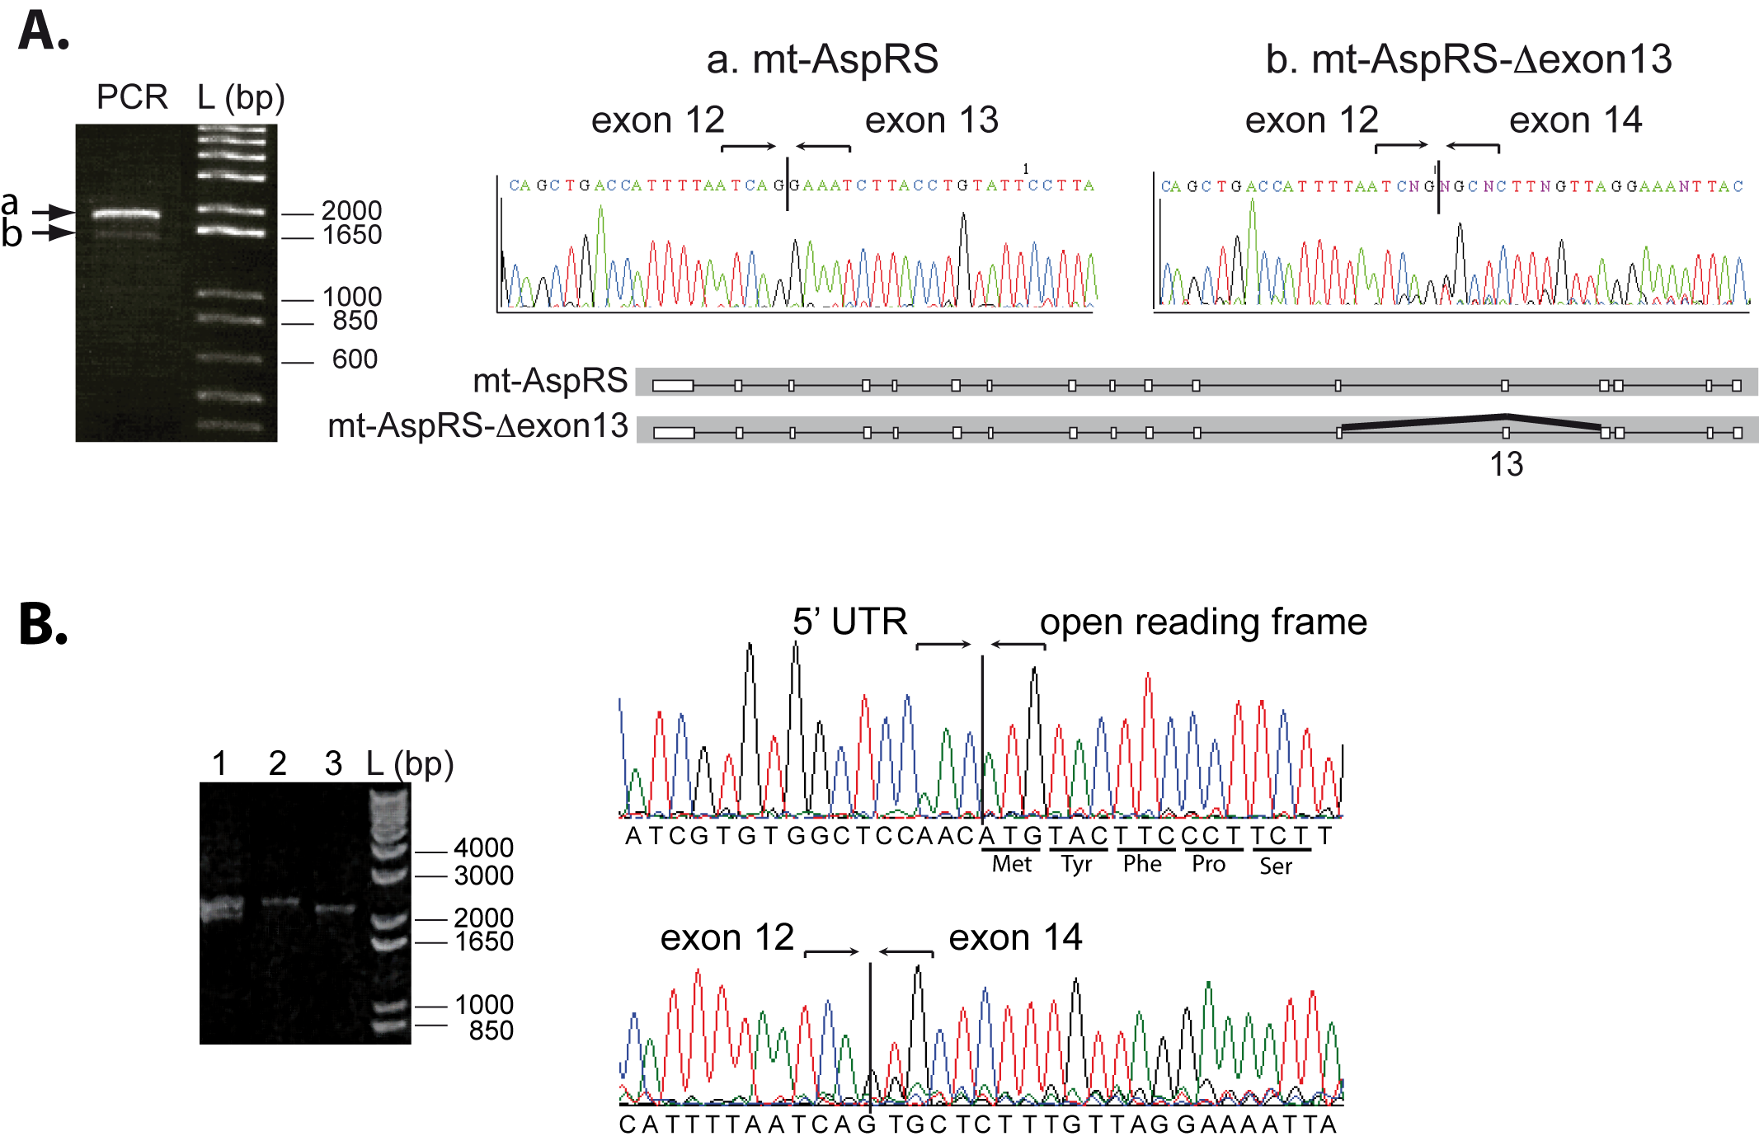

Figure 1: Co-existence of 2 mRNAs for human mt-AspRS. A. Two PCR products of mt-AspRS coding sequences are amplified from a human cDNA library (arrows). Sequencing of PCR amplified products identified the full-length mt-AspRS sequence (a) and a sequence deprived of the 153 nucleotides corresponding precisely to exon 13 (b). The scheme of corresponding pre-mRNAs organization is given (exons: white boxes; introns: lines). B. Detection of a full-length mt-AspRS-DExon13 mRNA. PCR fragments containing the complete open reading frame were generated with primers hybridizing within the 5’- and 3’-UTRs, resulting in two bands (lane 1). These two bands were cut separately and purified (lanes 2 and 3). Sequence analysis of the shorter of the two fragments focused on the region containing the start codon (upper part) and the region spanning exon 13 (lower part). It indicates that the open reading frame starts with expected amino acids for the MTS N-terminus. L stands for molecular weight ladder. All primer sequences are detailed in Supplementary Fig.1.

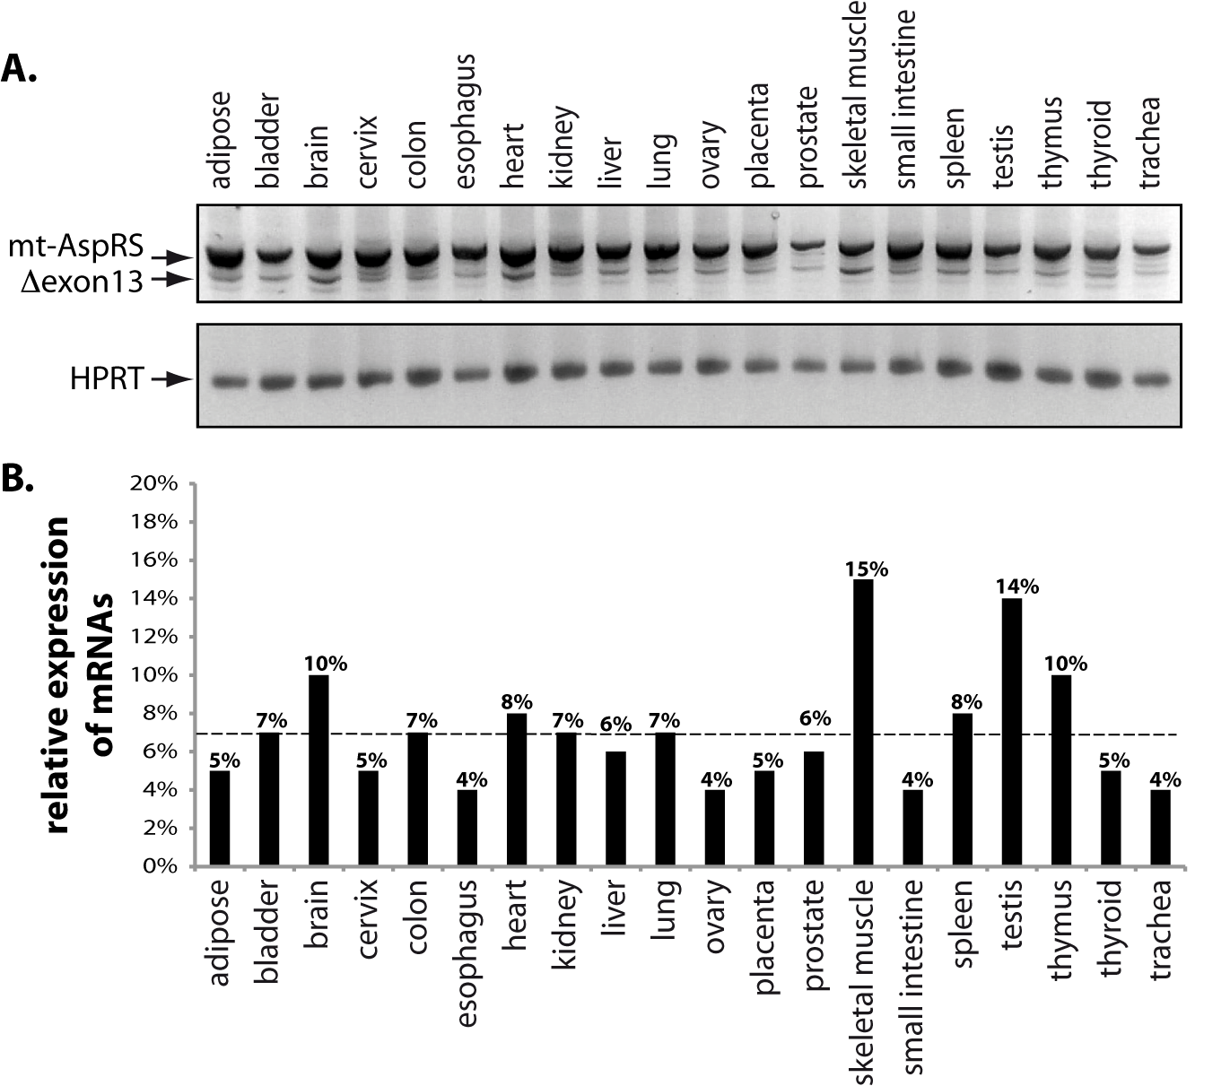
Figure 2. Both mRNAs coding for human mitochondrial aspartyl-tRNA synthetase full-length and splice-variant are expressed in different human tissues. PCR amplification of full-length and mt-AspRS-Dexon13 mRNAs using total cDNA from 20 different human tissues as templates, were carried out as described in Methods, with oligonucleotides hybridizing in neighboring exon 11 (forward) and 3’-UTR (reverse) (see Supplementary Fig. 1). Control PCR reactions with primers for hypoxanthine-guanine phosphoribosyl-transferase (HPRT) were included (lower panel). XXXX
Indiquer le nombre de réplicat biologiques
Donner un tableau supplementaire avec les valeurs de Ct
Compléter la légende de cette figure. Indiquer ce que sont A. et B. (préciser la dotted line = lean values

Figure 3: Section of MACS focus on BID from large number of bacterial AspRSs and mitochondrial AspRSs

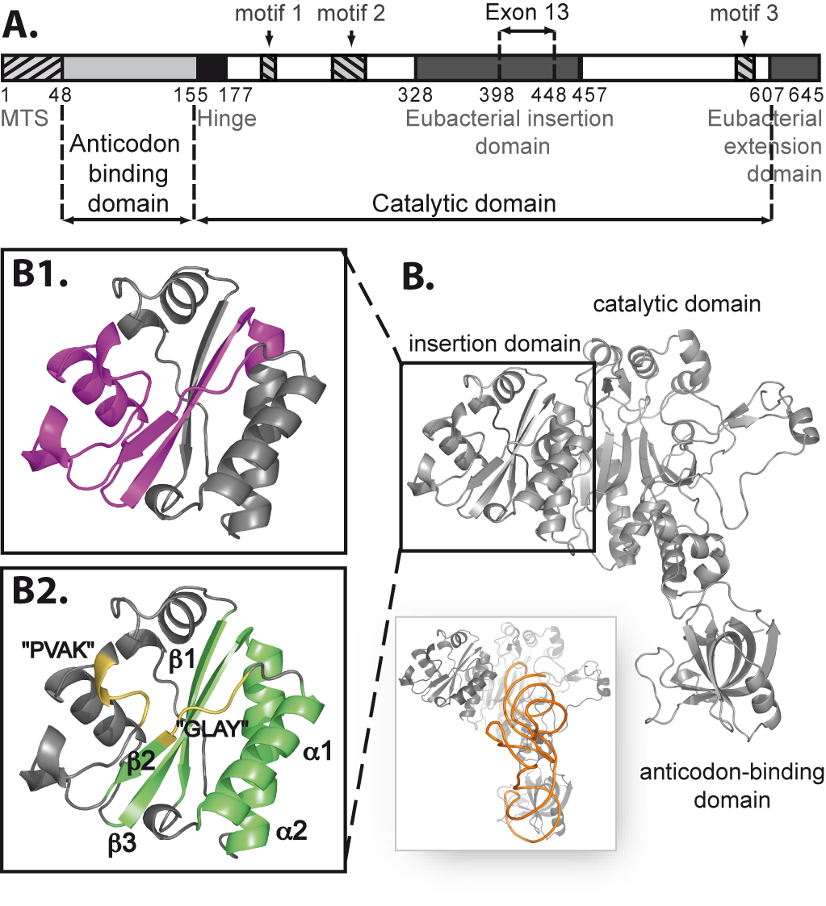
Figure 4. Exon13 peptide in mt-AspRS. A. Modular organization of full-length human mt-AspRS (including the mitochondrial targeting sequence, MTS) {Bonnefond, 2005 #7116}. B. Location of exon13 peptide in a crystallographic structure. E. coli AspRS in its complexed form with tRNA^{Asp} (see inset) {Eiler, 1999 #5140} was taken as model due to the high level of sequence identity {Bonnefond, 2005 #7116}. For simplicity, only one AspRS monomer is shown and major structural domains are indicated. B1. Exon13 (aa 348 – 402 in E. coli AspRS) is highlighted in magenta. B2. The bacterial insertion domain includes a ferredoxin-like fold b₁a₁b₂b₃a₂ (green) and signature motifs “GLAY” and “PVAK” (yellow) strongly conserved in eubacterial AspRSs (see text). Structures have been drawn using PyMol {DeLano, 2002 #6937}. REFAIRE SUR LA STRUCTURE XLLO DE L’enzyme humaine
SUPPLEMENTARY FIGURES AND METHODS

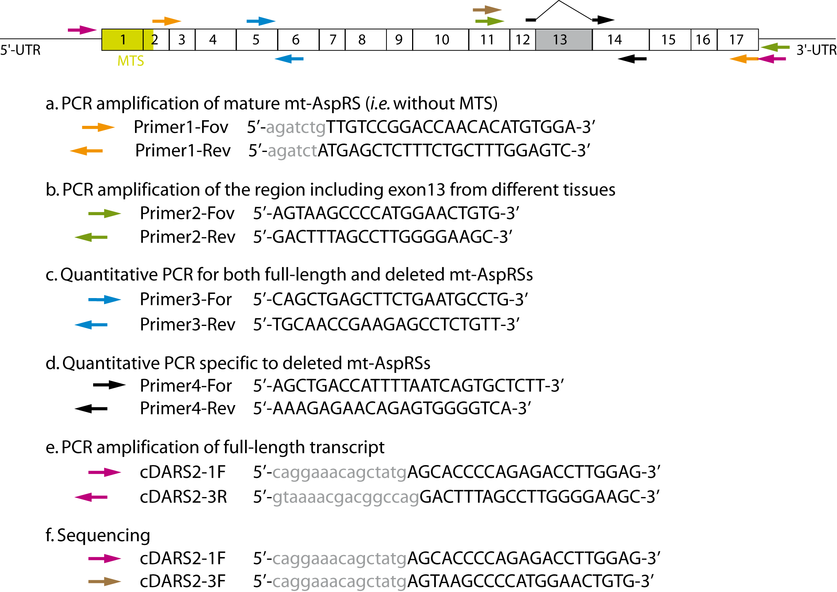

Supplementary Figure 1. Primers for mt-aaRS analyses. A. Location, experimental purposes and sequences of oligonucleotides specific to mt-AspRS. The scheme represents the full length mt-AspRS mRNA with boxes corresponding to the different exons. Exon 13 is highlighted in grey and MTS in green. B. Primers for PCR amplification of mature mt-LysRS, mt-ThrRS and mt-GluRS. In some oligonucleotides, lower case grey letters correspond to nucleotides which do not hybridize with mt-AspRS mRNA sequence, but have been added for cloning purposes. Purified oligonucleotides for mt-AspRS were either from Proligo (Boulder, CO) or Invitrogen. Those for mt-LysRS, mt-ThrRS and mt-GluRS were from Structural Biology and Genomics Platform (IGBMC, Illkirch).

Add primers for mouse, and if necessary, for Monkey

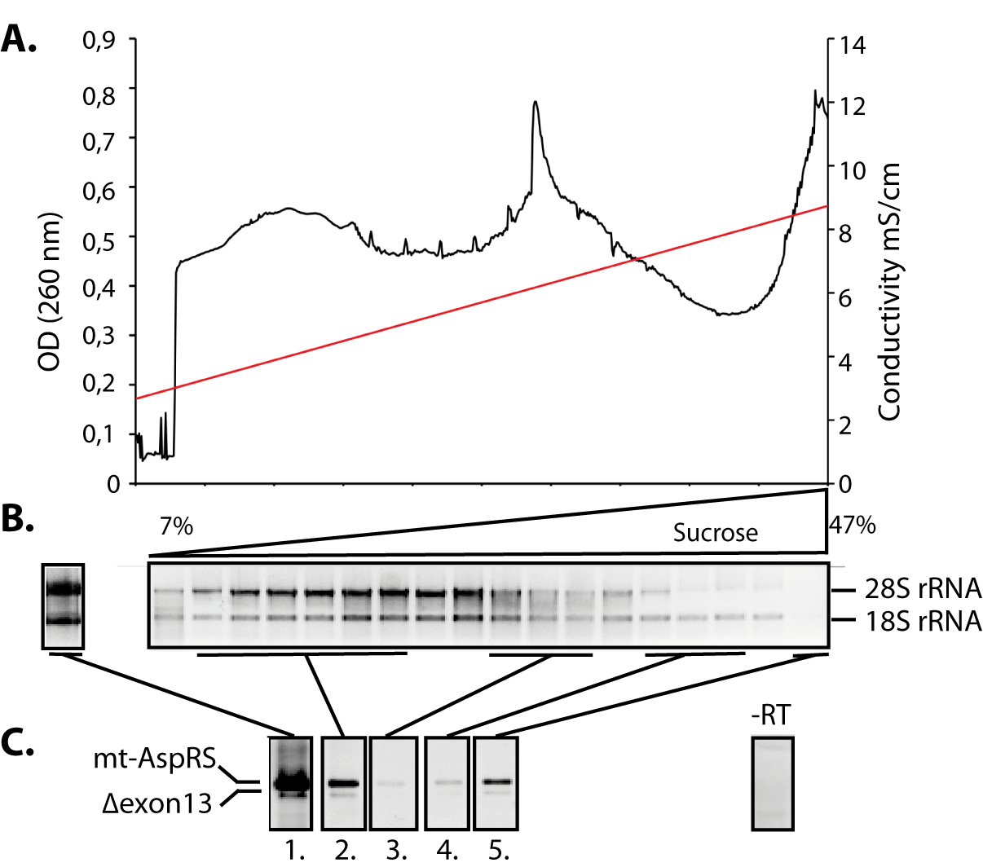
Supplementary Figure 2: Retrieval of polysome-associated mRNAs coding for mt-AspRS and mt-AspRS-Dexon13 from crude cytosolic extracts separated by sucrose gradient sedimentation. A. Representative absorbance profile for RNA separated on 7%-47% sucrose gradient. B. Analysis on a 1% agarose gel of aliquots of RNA extracted from each of the 18 fractions. Visualization of 28S and 18S rRNAs shows them as prominent RNA species and confirms the integrity of all RNA fractions. The left panel shows an aliquot of total RNA extracted from the cytolosic extract before loading on the sucrose gradient. C. Extracted RNAs were reversed transcribed using poly(dT) primers (specific for polyA-tails) and the obtained cDNAs were amplified with primers specific for both the full-length and exon 13-deleted mRNAs. Panels on the left correspond to total RNA loaded on gradient (1.), pooled polysome fraction (2.), pooled free 80S ribosome fraction (3.), pooled separated 60S and 40S ribosomal sub-units fraction (4.), and free or low density RNAs fraction (5.). Panel on the right corresponds to a representative control experiment were the reverse transcription step is omitted.
Indiquer le nombre de réplicats biologiques

Suppl. Fig. 3: show the all alignment as an html file
Suppl. Fig. 4: exon shuffling in other organisms

Suppl. Methods: Expression and purification of recombinant proteins. Numerous combinations of plasmids and E. coli strains were tested to over-express recombinant proteins. Transformants of E. coli TOP10 harboring pQE70-mt-AspRS-DExon13 were cultured in Luria-Bertani (LB) medium supplemented with 100 µg/ml ampicillin. Transformants of E. coli PGK JE7 (gift from M. Frugier, Strasbourg) harboring pQE70-mt-AspRS-DExon13 were cultured in LB medium supplemented with 100 µg/ml ampicillin, 100 µg/ml chloramphenicol and 2mg/ml L-arabinose. Transformants of E. coli PGK JE8 (gift from M. Frugier, Strasbourg) harboring pQE70-mt-AspRS-DExon13 were cultured in LB medium supplemented with 100 µg/ml ampicillin, 100 µg/ml chloramphenicol and 50 µg/ml tetracycline. Transformants of E. coli M15 (gift from L. Maréchal-Drouard, Strasbourg) harboring pQE70-mt-AspRS-DExon13 or pQE70-OmpA-mt-AspRS-DExon13 were cultured in LB medium supplemented with 100 µg/ml ampicillin and 25 µg/ml kanamycin. Transformants of E. coli BL21 derivative “Rosetta 2” (Novagen) and BL21(DE3)RIL harboring pQE70-mt-AspRS-DExon13, pDEST-(His)₆-MBP-mt-AspRS-DExon13 or pDEST-peri-(His)₆-MBP-mt-AspRS-DExon13 were cultured in LB medium supplemented with 100 µg/ml ampicillin and 100 µg/ml chloramphenicol. Transformants of E. coli ArcticExpress (gift from M. Mörl, Leipzig) harboring pDEST-(His)₆-MBP-mt-AspRS-DExon13 or pDEST-peri-(His)₆-MBP-mt-AspRS-DExon13 were cultured in LB medium supplemented with 100 µg/ml ampicillin and 20 µg/ml gentamycin. When the culture density reached an absorbance A₆₀₀ of 0.4-0.6, 20 µM to 1 mM of IPTG was added to induce protein expression and the cultivation was then continued at several temperatures ranging from 12°C to 37°C for an additional time varying between 3 hours to over-night. The cells were collected by centrifugation (1,700g) and frozen at -20°C until being analyzed.
Cells (from 20 ml cultures) were resuspended in 2 ml of one of the 7 different buffers (B1 to B7, see below). The suspension was sonicated on ice, three times during 30 seconds at 120 volts (Ultrasons Annemasse, France). The resulting crude extract was clarified by centrifugation (15,000g) at 4°C during 15 minutes. Aliquots from crude extracts, supernatants and pellets were analyzed on 12 % SDS-PAGE and were visualized by Coomassie staining. Diverse purifications were attempted on 2 liters of cell cultures by classical affinity chromatography and as previously described {Bonnefond, 2005 #7116}. When necessary, attempts to remove chaperon proteins were performed by increasing NaCl concentration to 0.5 M and/or by using 15% (v/v) isopropanol or 0.5% (v/v) Triton x100. B1: 50 mM NaH₂PO₄, pH 7.5, 300 mM NaCl, 20 mM imidazole and 10 % glycerol; B2: 100 mM MES, pH 6.1, 250 mM NaCl, 0,1 % triton, 10 mM β-mercaptoethanol and 10 % glycerol; B3: 100 mM MOPS, pH 7.0, 250 mM NaCl, 0,1 % triton, 10 mM β-mercaptoethanol and 10 % glycerol; B4: 100 mM NaH₂PO₄, pH 7.2, 250 mM NaCl, 0,1 % triton, 10 mM β-mercaptoethanol and 10 % glycerol; B5: 100 mM MOPS, pH 7.0, 250 mM NaCl, 10 mM MgCl₂ and 10 % glycerol; B6: 100 mM Tris-HCl, pH 8.1, 250 mM NaCl, 0,1 % triton, 10 mM β-mercaptoethanol and 10 % glycerol; B7: 50 mM NaH₂PO₄, pH 7.5, 300 mM NaCl, 20 mM imidazole, 10 mM β-mercaptoethanol and 10 % glycerol.

